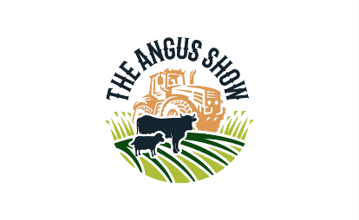
Angus Agricultural Show
Angus Companion Dog Show
Saturday 6TH June 2026– Haughmuir, Brechin Castle Showground, DD9 6RL
Held by the kind permission of The Kennel Club
Entries taken on the day at 12:30pm with the show commencing at 2:00pm.
Pedigree Classes
Class 1 – Any Variety Puppy (6 – 12 months)
Class 2 – Terrier & Hounds
Class 3 – Working & Pastoral
Class 4 – Utility & Toy
Class 5 – Gundog
Class 6 – Junior Handler (up to 16 years old)
Novelty Classes
Class 7 – Best Cross Breed
Class 8 – Most Appealing Eyes
Class 9 – Waggiest Tail
Class 10 – Dog The Judge Would Like To Take Home
Any questions or queries please contact – 07930 727516 (Show Secretary) or
Kayleigh Welsh on 07745 359535
SHOW SPONSERED BY:


